**DAILY ONLINE ACTIVITIES SUMMARY**

|  |  |  |  |  |
| --- | --- | --- | --- | --- |
| **Date:** | | **02-06-2020** | **Name:** | **Latika Kavoor** |
| **Sem & Sec** | | **4th Sem & A-Section** | **USN:** | **4AL18CS035** |
| **Online Test Summary** | | | | |
| **Subject** | **-** | | | |
| **Max. Marks** | **-** | | **Score** | **-** |
| **Certification Course Summary** | | | | |
| **Course** | | **RPA** | | |
| **Certificate Provider** | | **UiPath** | **Duration** | **3 hrs** |
| **Coding Challenges** | | | | |
| **Problem Statement:** Given an array arr[] of integers and an integer K, the task is to print all subsets of the given array with the sum equal to the given target K. | | | | |
| **Status: Completed** | | | | |
| **Uploaded the report in Github** | | | **Yes** | |
| **If yes Repository name** | | | <https://github.com/alvas-education-foundation/latika.kavoor/tree/master/coding_solutions> | |
| **Uploaded the report in slack** | | | **Yes** | |

Online Test Details: (Attach the snapshot and briefly write the report for the same)

No test was Conducted.

Certification Course Details: (Attach the snapshot and briefly write the report for the same)

I started with RPA course provided by UiPath. This course was suggested by our HOD. It was a 3 hour course and there were mcqs also to be solved in it. I have completed the course and have received certificate for the same.

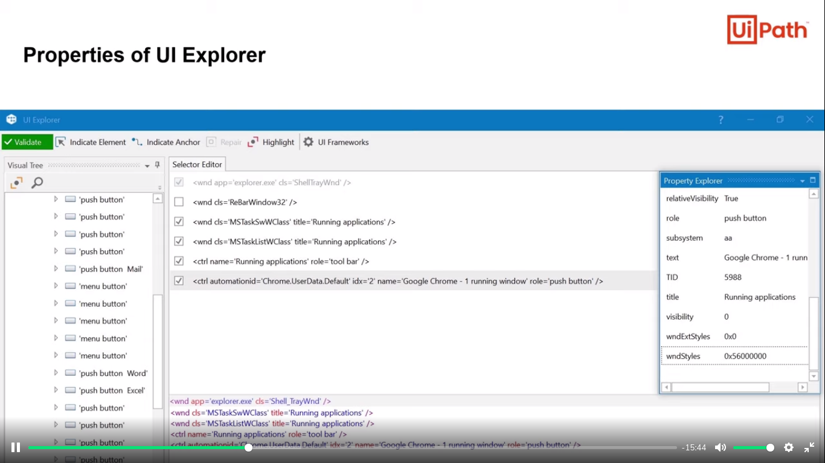

CERTIFICATE

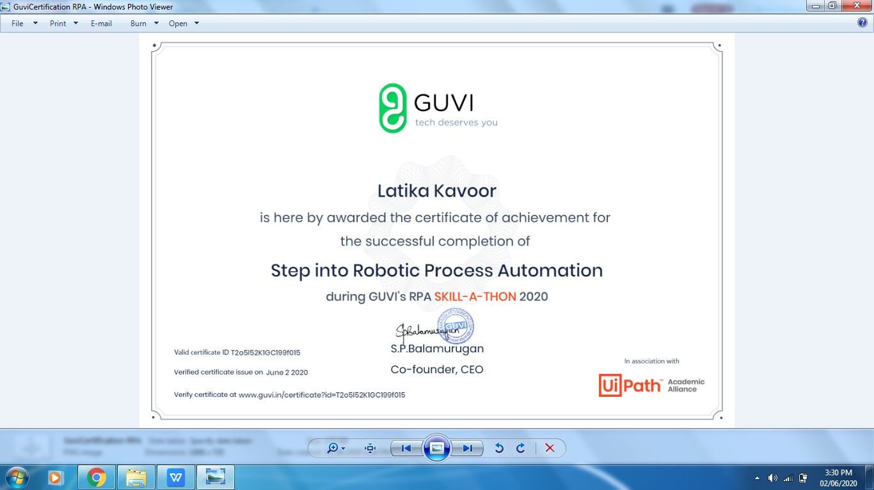

Coding Challenges Details: (Attach the snapshot and briefly write the report for the same)

Solved the problem and uploaded the same on github

